

International School

SOFTWARE PROJECT MANAGEMENT
CMU-IS 432 BIS

Research Report
Version 1.1
Date: May 14th, 2026

Sports Performance Analysis System Using Big Data

Ngoc, Tran Thi Bao | 30209256289
Hai, Huynh Thi | 30205127541
Trang, Dinh Thi Thu | 30201123797
Suong, Ung Thi Thu | 30206959173
Duc, Nguyen Nhu Minh | 30219263424

Approved by
Hoang, Le Kim

Proposal Review Panel Representative:
Name Signature Date

TABLE OF CONTENTS
INTRODUCTION 1
CHAPTER 1: SYSTEM OVERVIEW 2
1.1 Motivation for the Topic 2
1.2 System Objectives and User Roles 2
1.3 The Role of Big Data and AI in Sports Performance Analysis 2
CHAPTER 2: SYSTEM ANALYSIS 3
2.1 Main Functionalities of the System 3
2.1.1 Data Ingestion & Synchronization 3
2.1.2 Athlete Roster & Insight Visualization 3
2.1.3 AI-Powered Predictive Analytics 4
2.1.4 Interactive Terminal Dashboard 4
2.2 Use Case Diagrams & Use Case Specifications 4
2.3 Activity Diagrams 16
2.4 System Architecture 17
2.5 JWT Authentication Functions 19
2.5.1 JWT Login Flow 19
2.5.2 Email Verification Flow 19
2.5.3 Refresh Token Flow 19
2.5.4 Logout Flow 20
2.5.5 Additional Use Cases 20
2.6 Overall System Workflow 20
2.7 System Requirements 20
CHAPTER 3: DATABASE DESIGN 21
3.1 ERD Diagram 21
3.2 Main Collections 22
CHAPTER 4: BACKEND DEVELOPMENT & API 22
4.1 Backend Structure 22
4.2 API List and Processing Flows 23
4.2.1 User Management API 23
4.2.2 API for processing logic and retrieving data from the Football API 28
4.3 Authentication and Authorization System (JWT Authentication) 32
4.3.1 JWT Flow 32
4.3.2 API Protection Middleware Structure 32
4.3.3 List of Authentication APIs 32
CHAPTER 5: INTERFACE DESIGN & DASHBOARD (4 pages) 33
5.1 Functional Screens 33
5.2 Statistical Charts & Visualizations 35
CHAPTER 6: DATA ANALYSIS 36
6.1 Data is collected from the API-Football service 36
6.2 Data Preprocessing 37
6.2.1 Data Cleaning 37
6.2.2 Selecting Valid Matches 38
6.2.3 Sorting Data by Time 38
6.3 Converting JSON into Dataset 38
6.4 Feature Engineering (AI Prediction) 38
6.4.1 Collecting the Latest 5 Matches of Each Team 39
6.4.2 Calculating Average Statistics 39
6.5 AI Training 39
6.5.1 Preparing Training Data 39
6.5.2 Data Labeling 40
6.5.3 Splitting Training and Testing Data 40
6.5.4 Selecting AI Models 41
6.5.5 AI Training Process 41
6.5.6 Evaluating the AI Model 42
6.5.7 Model Optimization 42
CHAPTER 7: CONCLUSION 43
7.1 Achieved Results 43
7.2 Limitations & Future Work 43
REFERENCES 44

LIST OF FIGURES
Figure 1: Use Case Diagram for User Login Process 4
Figure 2: Use Case Diagram for Athlete Statistics Viewing and Filtering 7
Figure 3: Use Case Diagram for Athlete Statistics Viewing and Filtering 10
Figure 4: Use Case Diagram for External Data Synchronization 13
Figure 5: Activity Diagram for AI Prediction Workflow 16
Figure 6: Activity Diagram for System Data Sync Process 16
Figure 7: System Architecture Overview 17
Figure 8: ERD of the Sports Performance Analysis System 22
Figure 9: Backend Processing Flow and System Interaction Pipeline 23
Figure 10: User Authentication Sequence Diagram 24
Figure 11: Performance Data Import Sequence Diagram 25
Figure 12: Sequence Diagram – Save Performance Data to Database 25
Figure 13: Sequence Diagram – Backend Processing Workflow 26
Figure 14: Sequence Diagram – Dashboard Display Flow 27
Figure 15: Sequence Diagram – Data Analysis Workflow 27
Figure 16: General Backend Flow Diagram 28
Figure 17: Backend Code for Calling the Football API 29
Figure 18: Match Data Normalization Function 30
Figure 19: Backend API Routing Structure (Express Router) 31
Figure 20: Frontend API Handling Logic 31
Figure 21: Frontend Axios Client Configuration 32
Figure 22: Sample Raw JSON Data Returned from API-Football 37
Figure 23: Example of Structured Dataset Converted from JSON 38

LIST OF TABLES
Table 1: System Requirements Specification Table 21
Table 2: System Database Collections and Their Functional Purposes 22
Table 3: List of Authentication APIs 32

INTRODUCTION
In recent years, the rapid development of digital technologies has significantly transformed the sports industry. The emergence of Big Data, wearable tracking devices, and automated analytical systems has enabled coaches and sports organizations to move beyond intuition-based decision-making toward evidence-based performance optimization. As the competitiveness of professional sports continues to rise, even minor improvements in athlete performance can lead to substantial competitive advantages.
Traditional methods of performance evaluation—such as manual observation and subjective assessment—are no longer sufficient to handle the increasing complexity and volume of sports data. Modern training environments require systems that can collect, process, and visualize large datasets efficiently and accurately. From physiological measurements such as heart rate and stamina, to tactical positioning and match statistics, data has become an indispensable resource for athlete development and strategic planning.
This project focuses on designing and developing a Sports Performance Analysis System that leverages Big Data technologies to support coaches and administrators. The system integrates multiple components including user authentication, athlete management, performance data entry, analytical dashboards, and visualization modules. With a structured architecture built on modern web technologies (Next.js, React, Node.js, MongoDB), the system aims to provide a reliable, scalable, and user-friendly platform for monitoring athlete performance.
The overarching goal of the project is to transform raw sports data into meaningful insights that can assist in training optimization, injury prevention, and strategic decision-making. Beyond supporting performance analytics, the system also incorporates secure authentication mechanisms (JWT-based Login, Register, Logout) to ensure data confidentiality and controlled access for different user roles.
This report presents the full development process of the system—from requirement analysis and database design to backend API implementation and dashboard visualization. Through this project, the team aims to contribute a practical solution that aligns with current trends in data-driven sports management and demonstrates the real-world application of Big Data in athletic performance enhancement.

CHAPTER 1: SYSTEM OVERVIEW

1.1 Motivation for the Topic
In the digital era, Big Data has become the “new gold” across various industries, and sports is no exception. Modern athlete and team management no longer rely solely on intuition or coaching experience, but instead on concrete, data-driven evidence.
- Explosion of data: Wearable devices, field sensors, and AI-powered cameras can collect millions of data points per match (heart rate, distance covered, processing speed, etc.).
- Performance optimization: Big Data enables detection of micro-patterns that the human eye cannot observe, helping athletes improve performance and reduce injury risk.
- High competitiveness: In professional sports, a 1% improvement in performance can determine victory or defeat. Data-driven systems help teams make faster and more accurate strategic decisions.
Therefore, building a system capable of storing, processing, and visualizing performance data is essential to transform raw numbers into actionable insights.

1.2 System Objectives and User Roles
The system is designed to support two primary user groups with an emphasis on data-driven decision-making:
Admin
- System Governance: Manage users, roles, and system configurations.
- Infrastructure Monitoring: Monitor data collection, storage, and the stability of AI processing services.
- Security Management: Ensure data integrity, cybersecurity, and handle technical escalations.
Coach
- Performance Monitoring: Track athlete metrics via intuitive dashboards and real-time reports.
- Strategic Forecasting: Use AI Hub to predict match outcomes, team win probabilities, and player performance scores.
- Risk Mitigation: Analyze AI-generated alerts regarding overtraining or injury risks to protect athlete health.
- Smart Planning: Utilize the Virtual Assistant to query complex data and optimize team lineups based on predictive evidence.

1.3 The Role of Big Data and AI in Sports Performance Analysis
Big Data and Artificial Intelligence form the backbone of the system, transforming raw information into competitive advantages.
The Foundation of Big Data (The 3Vs):
- Volume: Processing massive datasets from historical matches and seasons that manual analysis cannot handle.
- Velocity: Analyzing high-speed data streams from live matches and API updates for immediate insights.
- Variety: Merging diverse data types, including tactical statistics, physical health metrics, and external match data.
The Power of Artificial Intelligence (AI):
While Big Data provides the information, AI acts as the "intelligence" to extract value. In this system:
- Predictive Modeling: Algorithms like Random Forest analyze historical patterns to forecast future results (e.g., Match Scores, Win Confidence).
- Actionable Insights: AI identifies micro-patterns to detect early signs of performance decline or injury potential.
- Natural Language Interaction: Integrating a Virtual Assistant (Chatbot) allows coaches to interact with Big Data using natural language, making complex analytics accessible to non-technical users.

CHAPTER 2: SYSTEM ANALYSIS

2.1 Main Functionalities of the System
The system focuses on aggregating, processing, and analyzing real-world football data through specialized modules:

2.1.1 Data Ingestion & Synchronization
- Real-time API Integration: Automatically fetch match results, standings, and player statistics from professional Football APIs (e.g., API-Football).
- Automated Standardization: Process and normalize raw JSON data from external sources into a structured format stored in MongoDB.
- Large-scale Data Sync: Handle high volumes of historical match data to provide a comprehensive database for the AI engine.

2.1.2 Athlete Roster & Insight Visualization
- Live Roster Display: View a dynamic list of players and clubs with real-time updated metrics (Goals, Assists, Pass Accuracy).
- Performance Intelligence: Visualize historical performance trends using interactive charts based on authentic match data.

2.1.3 AI-Powered Predictive Analytics
- Match Outcome Forecasting: Predict scores and win/draw/loss probabilities for upcoming fixtures using the Random Forest model.
- AI Confidence Scoring: Calculate the reliability of each prediction, as demonstrated in the "AI Hub" module.
- Automated Pattern Detection: Identify performance anomalies and potential fatigue risks based on actual match intensity.

2.1.4 Interactive Terminal Dashboard
- System-wide Statistics: Display macro-level data such as total teams, matches analyzed, and the current accuracy rate of the AI model.

2.2 Use Case Diagrams & Use Case Specifications
The system includes four main Use Cases:
2.2.1 Use Case: Login
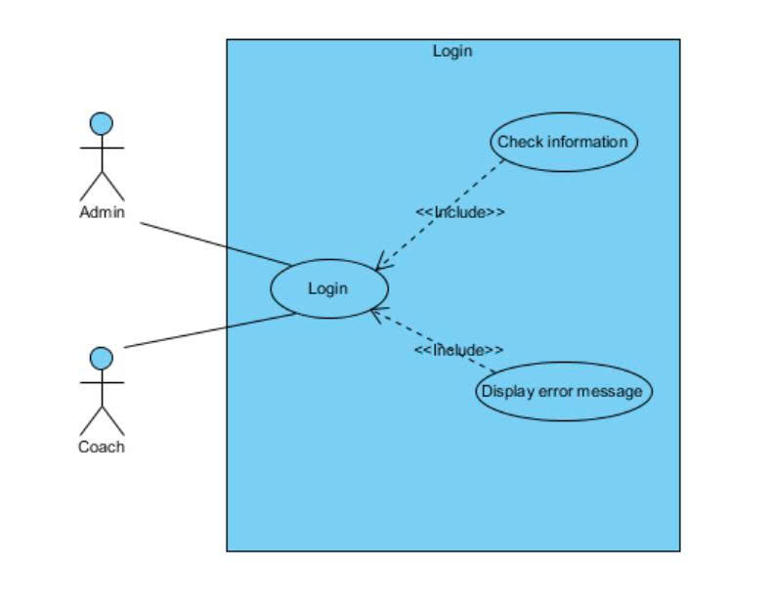
Figure 1: Use Case Diagram for User Login Process

Use Case ID | UC.01
Use Case Name | Login to the System
Created by | Bao Ngoc |  | Last updated by |  | Bao Ngoc
Date Created | Apr 10, 2026 |  | Date last updated |  | Apr 10, 2026
Actors | Admin  Coach
Brief Description | This use case describes the process in which a user enters login information to access the system.
Goal | Allow users to authenticate their identity and access the system according to their assigned roles.
Trigger | The user navigates to the login page and performs the login action.
Pre-conditions | - The user must already have a valid account in the system.  - The system is operating normally  - The database connection is available
Post-conditions | Success:  - The user logs in successfully  The system redirects the user to the Dashboard / Home page  Failure:  - An appropriate error message is displayed  - Access is denied
Main Flow | Step | Actor Action |  | System Response
Main Flow | 1 | Accesses the login page |  | Displays the login form (username + password)
Main Flow | 2 | Enters a valid username and password
Main Flow | 3 | Clicks "Login" |  | Sends login data to the server
Main Flow | 4 |  |  | Validates login information
Main Flow | 5 |  |  | If valid → creates session
Main Flow | 6 |  |  | Redirects to the Dashboard
Main Flow | 7 | Accesses the system |  | The system displays the main interface
Alternative Flow | Alternative Flow 1: Incorrect Login Information
Alternative Flow | Step | Actor Action |  | System Response
Alternative Flow | 1 | Enters incorrect username or password
Alternative Flow | 2 | Clicks "Login" |  | Validates data
Alternative Flow | 3 |  |  | Detects invalid credentials
Alternative Flow | 4 |  |  | Displays error: “Incorrect username or password”
Alternative Flow | 5 | Re-enters information |  | Returns to Step 2
Exception Flow | Exception Flow 1: Database Connection Lost
Exception Flow | Step | Actor Action |  | System Response
Exception Flow | 1 | Enters login information
Exception Flow | 2 | Clicks "Login" |  | Fails to connect to the database
Exception Flow | 3 |  |  | Displays: “Unable to connect to the system.”
Exception Flow | 4 | Tries again later
Exception Flow | Exception Flow 2: Missing Input Fields
Exception Flow | Step | Actor Action |  | System Response
Exception Flow | 1 | Leaves username/password empty
Exception Flow | 2 | Clicks "Login" |  | Validates input
Exception Flow | 3 |  |  | Displays: “Please enter all required information”
Exception Flow | 4 | Enters input again |  | Returns to main flow
Priority | High
Business Rule | - Password must contain at least 8 characters.  - An account may be locked after three consecutive failed login attempts.

2.2.2 Use Case: View & Filter Athlete Stats
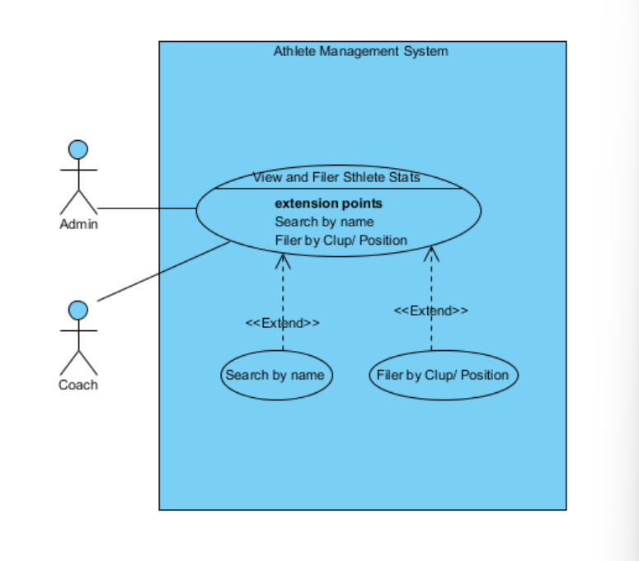
Figure 2: Use Case Diagram for Athlete Statistics Viewing and Filtering

Use Case ID | UC.02
Use Case Name | View & Filter Athlete Stats
Created by | Bao Ngoc |  | Last updated by |  |  | Bao Ngoc
Date Created | Apr 10, 2026 |  | Date last updated |  |  | Apr 10, 2026
Actors | Admin  Coach
Brief Description | This use case allows Coach and Admin to view, search, and filter player/team statistical data stored in the system using real football data synchronized from the API.
Goal | Helps users quickly and efficiently search, monitor, compare, and analyze athletes’ statistical performance data.
Trigger | The user accesses the “Player Roster” or “Clubs Database” module in the system.
Pre-conditions | - The user has logged into the system.  - The user has Coach or Admin permissions.  - Player data already exists in MongoDB.  - The system is successfully connected to the database.
Post-conditions | Success:  - The player statistics list is displayed correctly.  - The search/filter results are updated successfully.  Failure:  - No data is displayed.  - The system displays an appropriate error message
Main Flow | Step | Actor Action |  | System Response
Main Flow | 1 | The user accesses the “Player Roster” or “Clubs Database” module in the system. |  | The system sends a query to MongoDB to retrieve player/team data.
Main Flow | 2 |  |  | The system displays a statistics list including: Goals, Assists, Pass Accuracy, Matches Played, Position, and Club.
Main Flow | 3 | The user enters a search keyword or selects filters such as: Player Name, Club, Position, and League. |  | The system processes the search/filter conditions.
Main Flow | 4 |  |  | The system updates the corresponding result list.
Main Flow | 5 | The user views and compares statistical metrics. |  | The system displays the updated statistical data.
Alternative Flow | Alternative Flow 1: Missing input data.
Alternative Flow | Step | Actor Action |  | System Response
Alternative Flow | 1 |  |  | The system checks the input data.
  The user selects a match/player for analysis.
Alternative Flow | 2 |  |  | The system detects insufficient match/player data.
Alternative Flow | 3
  Displays: “Insufficient data for prediction.”
Alternative Flow | Alternative Flow 2: AI Service Does Not Respond
Alternative Flow | Step | Actor Action |  |  | System Response
Alternative Flow | 1 | The user clicks the “Predict” or “Run Analysis” button. |  | The system sends data to the AI Service.
Alternative Flow | 2 |  |  | The Python Service encounters an error or timeout.
Alternative Flow | 3 |  |  | Displays: “Prediction service unavailable.”
Exception Flow | Exception Flow 1: System Error / Database Connection Failure
Exception Flow | 1 | Performs an action |  | The system cannot access the database
Exception Flow | 2 |  |  | Displays: “Connection error. Please try again later.”
Priority | High
Business Rule | - Statistical data is synchronized from the Football API.  - Only Coach and Admin roles are authorized to access statistical data.  - The displayed data must reflect real-world football statistics accurately.  - The search and filter functions must dynamically update results based on the user’s selected conditions.

2.2.3 Use Case: Run Predictive Analysis
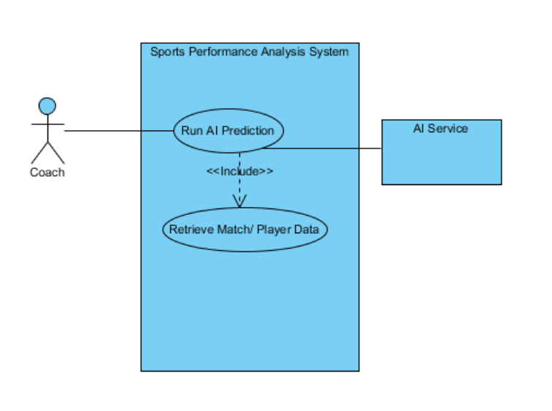
Figure 3: Use Case Diagram for Athlete Statistics Viewing and Filtering

Use Case ID | UC.03
Use Case Name
  Run Predictive Analysis (AI Hub)
Created by | Thu Trang |  | Last updated by |  | Thu Trang
Date Created | May 11, 2026 |  | Date last updated |  | May 11, 2026
Actors | Admin  Coach
Brief Description | This use case allows the Coach to run AI-based predictive analysis using historical match and player data. The system retrieves relevant data, sends it to the AI service (Python/Random Forest), and returns prediction results and recommendations.
Goal | To provide intelligent predictions and recommendations that help the Coach make better strategic decisions.
Trigger | The Coach selects the “Run AI Prediction” function from the AI Hub dashboard.
Pre-conditions | - The Coach is logged into the system.  - Match and player data are available in the database.  - AI Service is running and accessible.  - The system is operating normally.
Post-conditions | Success:  - Prediction results are generated and displayed.  - Recommendations are stored in the system (optional).  Failure:  - No prediction is generated.  - An error message is displayed to the Coach.
Main Flow | Step | Actor Action |  | System Response
Main Flow | 1 | Accesses the AI Hub and selects “Run AI Prediction” |  | The system opens the prediction interface
Main Flow | 2 | Selects prediction parameters (team, players, match, model options) |  | The system validates the input
Main Flow | 3 | Clicks “Run Prediction” |  | The system processes the request
Main Flow | 4 |  |  | The system retrieves match and player data from MongoDB
Main Flow | 5 |  |  | The system sends the data to the AI Service (Python/Random Forest)
Main Flow | 6 |  |  | The AI Service returns prediction results
Main Flow | 7 |  |  | The system displays predictions, probabilities, and recommendations
Main Flow | 8 | Optionally saves or exports the results
  The system stores or downloads the results
Alternative Flow | Alternative Flow 1: View Existing Predictions
Alternative Flow | Step | Actor Action |  | System Response
Alternative Flow | 1 | Opens the prediction history |  | The system displays previous predictions
Alternative Flow | 2
  Selects a record
  The system shows detailed results
Alternative Flow | Alternative Flow 2: Export Prediction Report
Alternative Flow | Step | Actor Action |  | System Response
Alternative Flow | 1 | Clicks “Export Report” |  | The system generates a PDF/Excel file
Alternative Flow | 2
  Downloads the file
  The report is saved to the user’s device
Alternative Flow | Alternative Flow 3: Save Recommendations
Alternative Flow | Step | Actor Action |  | System Response
Alternative Flow | 1 | Clicks “Save Recommendations” |  | The system stores recommendations in the database
Alternative Flow | 2 |  |  | The system displays “Saved successfully”
Alternative Flow | Alternative Flow 4: Cancel Prediction
Alternative Flow | Step | Actor Action |  | System Response
Alternative Flow | 1 | Clicks “Cancel” during setup
  The system closes the prediction interface
Alternative Flow | 2
  No prediction is generated
Exception Flow | Exception Flow 1: Missing or Invalid Data
Exception Flow | Step | Actor Action |  | System Response
Exception Flow | 1 | Starts a prediction with incomplete or invalid parameters |  | The system validates the input data
Exception Flow | 2 |  |  | Displays: “Invalid or incomplete information”
Exception Flow | 3 | Re-enters correct data |  | The system returns to the prediction input form
Exception Flow | Exception Flow 2: AI Service or Database Connection Failure
Exception Flow | 1 |  |  | The system attempts to retrieve data and connect to the AI Service
  Clicks “Run Prediction”
Exception Flow | 2 |  |  | Displays: “Connection error. Please try again later.”
Priority | High
Business Rule | - Each prediction request must be associated with a valid Coach account.  - Match and player data must exist before prediction can be executed.  - Required fields must not be left empty.  - The AI Service and database must be available and accessible.

2.2.4 Use Case: System Data Sync (Admin only)
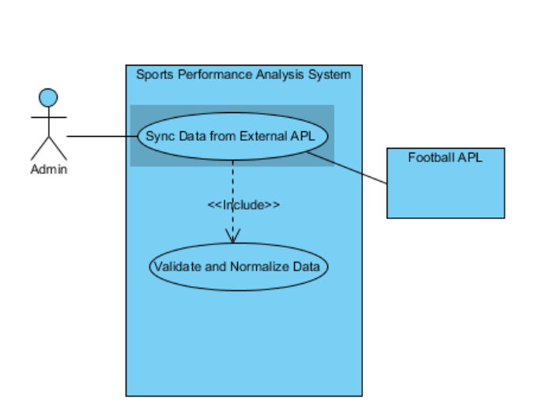
Figure 4: Use Case Diagram for External Data Synchronization

Use Case ID | UC.04
Use Case Name
  System Data Sync
Created by | Thu Trang |  | Last updated by |  | Thu Trang
Date Created | May 11, 2026 |  | Date last updated |  | May 11, 2026
Actors | Admin  Coach
Brief Description | This use case allows the Admin to synchronize football data from an external Football API into the system database. The system retrieves data, validates and normalizes it, then stores it in MongoDB.
Goal | To keep the system database updated with the latest football data from external sources.
Trigger | The Admin selects the “Sync Data from External API” function.
Pre-conditions | - The Admin is logged into the system.  - The Football API service is available.  - The system is connected to MongoDB.  - The system is operating normally.
Post-conditions | Success:  - Data is successfully synchronized and stored in MongoDB.  - The latest data becomes available in the system.  Failure:  - No data is updated.  - An error message is displayed to the Admin.
Main Flow | Step | Actor Action |  | System Response
Main Flow | 1 |  |  | The system displays the sync interface
  Accesses the data synchronization function
Main Flow | 2 | Clicks “Sync Data from External API” |  | The system starts the synchronization process
Main Flow | 3 |  |  | The system requests data from the Football API
Main Flow | 4
  The Football API returns football data
Main Flow | 5
  The system validates and normalizes the retrieved data
Main Flow | 6 |  |  | The system stores the processed data into MongoDB
Main Flow | 7 |  |  | The system displays “Synchronization completed successfully”
Alternative Flow | Alternative Flow 1: Partial Data Update
Alternative Flow | Step | Actor Action |  | System Response
Alternative Flow | 1 |  |  | The system synchronizes only the selected data
  Selects a specific dataset to synchronize
Alternative Flow | 2 |  |  | The updated data is stored successfully
Alternative Flow | Alternative Flow 2: Cancel Synchronization
Alternative Flow | Step | Actor Action |  | System Response
Alternative Flow | 1 | Clicks “Cancel” during synchronization |  | The system stops the sync process
Alternative Flow | 2
  No changes are made to the database
Exception Flow | Exception Flow 1: External API Connection Failure
Exception Flow | Step | Actor Action |  | System Response
Exception Flow | 1 |  |  | The system attempts to connect to the Football API
  Starts synchronization
Exception Flow | 2 |  |  | Displays: “Unable to connect to Football API. Please try again later.”
Exception Flow | Exception Flow 2: Invalid or Corrupted Data
Exception Flow | Step | Actor Action |  | System Response
Exception Flow | 1 |  |  | The system validates the retrieved data
  The system receives invalid or incomplete data
Exception Flow | 2 |  |  | Displays: “Data validation failed. Synchronization aborted.”
Priority | High
Business Rule | - Only Admin users can perform data synchronization.  - Retrieved data must be validated and normalized before storing in MongoDB.  - Duplicate or corrupted data must not be saved.  - The Football API must be accessible during synchronization.  - Required fields must not be empty.

2.3 Activity Diagrams
2.3.1. Activity: Run AI Prediction
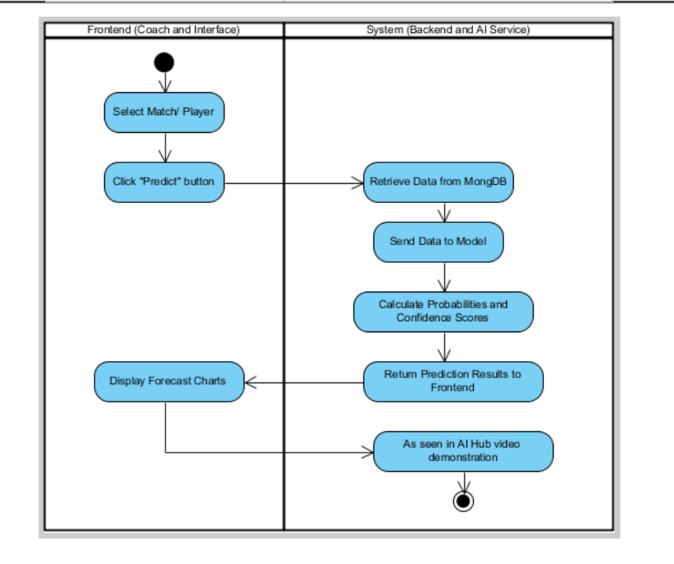
Figure 5: Activity Diagram for AI Prediction Workflow
2.3.2 Activity: System Data Sync
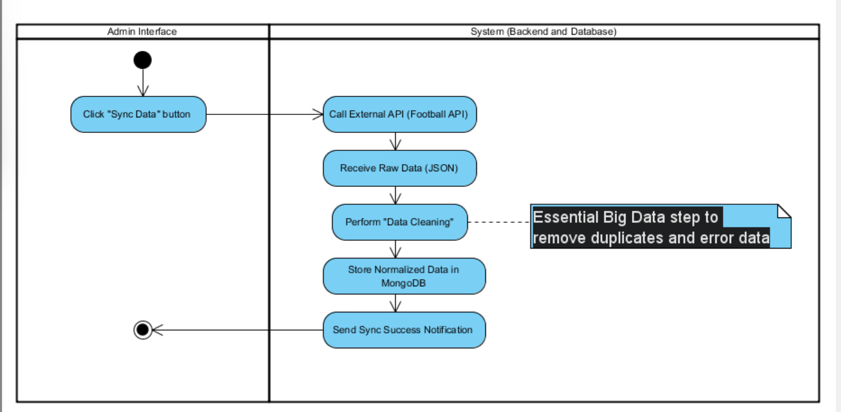
Figure 6: Activity Diagram for System Data Sync Process

2.4 System Architecture
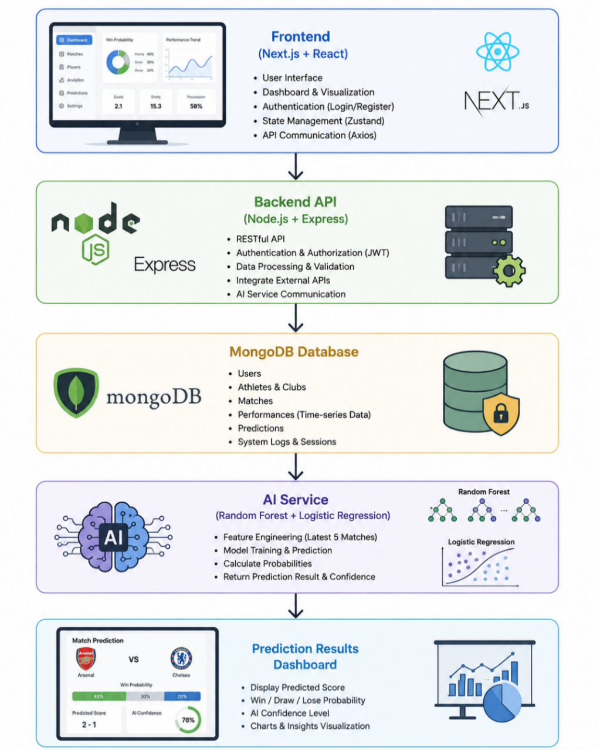
Figure 7: System Architecture Overview

The system is designed using a Multi-tier Architecture, optimized for high-performance Big Data processing and AI-driven insights.
2.4.1 Presentation Layer (Frontend)
Technologies Used
- Next.js – handles user authentication (Login / Register) and routing.
- React (JavaScript/JSX) – renders the main dashboard interface.
- Tailwind CSS – designs the login and UI components.
- Zustand – manages application state.
- Axios – communicates with backend APIs
Key Functions:
- User Authentication & Authorization (Admin vs. Coach).
- Performance Data Entry and Visualization.
- Rendering complex Charts and Statistical Tables.
2.4.2 Business Logic Layer (Backend & API)
Technologies Used
- Node.js
- Express.js
Data Sources
- External Football API
  - Backend fetches raw data
  - Processes, filters, and standardizes data
  - Exposes custom endpoints for frontend consumption
Key Responsibilities:
- Authentication Engine: Managing JWT and Refresh Token mechanisms.
- Data Normalization: Transforming unstructured third-party data into a consistent format.
- AI Integration: Preparing feature sets (Latest 5 matches) and communicating with the AI service to retrieve match outcome probabilities.
2.4.3 Data Layer (Database)
Database Used
- MongoDB
Stored Data Includes
- Users: Accounts, passwords (hashed), and roles.
- Athletes & Clubs: Profile data synced from external sources.
- Match & Performance: Time-series statistics (heart rate, speed, goals).
- System Logs & Sessions: Tracking activity and security tokens.
2.4.4 AI Service Layer (The Intelligence Core)
This layer is responsible for turning raw data into actionable predictions.
- Model Implementation: Utilizes Random Forest and Logistic Regression.
- Feature Engineering: Extracts the Latest 5 Matches for each team to calculate the "Current Form" indicators.
- Output: Returns predicted scores and an AI Confidence Level (%).
2.4.5 Actual System Workflow
The data flows through the system in a structured sequence:
- Authentication: Users log in via Next.js, which verifies credentials against MongoDB.
- Data Ingestion: The Node.js backend fetches data from the Football API.
- Processing: Data is cleaned and stored in the Database.
- Prediction Request: From the React Dashboard, the Coach requests a match prediction.
- AI Execution: The backend prepares the Dataset, the AI model analyzes it, and sends back the result.
- Visualization: Axios delivers the result to the UI, where React and Tailwind render the final prediction and charts.

2.5 JWT Authentication Functions

2.5.1 JWT Login Flow
→ Users access the login page built with Next.js and Tailwind CSS.
→ Login information is sent to the backend via Axios.
→ The backend (Express.js on Node.js) authenticates users using JWT and issues an access token + refresh token.
→ After successful authentication, users are assigned roles (Admin, Coach) and redirected to the dashboard.

2.5.2 Email Verification Flow
→ Users (Coach) interact with the dashboard interface built with React (JSX).
→ Data is entered in two ways:
Manual entry via form
File upload (CSV/Excel)
→ State is managed by Zustand before being sent to the server.

2.5.3 Refresh Token Flow
- Transmission: After being processed, the data is transferred through the Backend API.
- Storage (Dataset): The backend processes and stores data in MongoDB based on the core data schemas:
- User Schema: Manages user accounts and access permissions.
- Athlete Schema: Stores detailed athlete information.
- Performance Schema: Stores performance indicators and training metrics.
- Mechanism: Ensures data integrity among datasets during update or refresh operations.

2.5.4 Logout Flow
- Dataset Processing: The backend performs advanced data management operations:
- Calculation: Converts raw data into Key Performance Indicators (KPIs).
- Filtering & Aggregating: Classifies and summarizes data by time period or target object.
- Normalizing: Synchronizes data retrieved from external Football APIs with internal system data.
- Integration: Flexibly combines internal datasets with API datasets to create a comprehensive dataset for analysis purposes.

2.5.5 Additional Use Cases
→ Frontend (React JSX) calls the API through Axios (with an Interceptor that automatically refreshes the token when it expires).
→ Data is displayed in the form of:
Charts
Statistics tables
KPI indicators
→ Helps users monitor performance visually.

2.6 Overall System Workflow
In this 6-step workflow, the Dataset appears at two critical points:
- From a storage perspective: It is located in Step 3. Without datasets (such as Athlete and Performance tables), there would be no data to store.
- From a logical perspective: It is located in Step 4. The backend requires a sufficiently large and clean dataset to perform calculations and comparisons effectively.

2.7 System Requirements

Table 1: System Requirements Specification Table
No. | Requirement | Detailed Description
1 | Authentication & Authorization | The system must authenticate users and manage access permissions (Admin / Coach) using the JWT mechanism.
2 | Athlete Management | Provide functions to add, edit, delete, and view athlete lists (CRUD operations).
3 | Performance Data Input | Support manual data entry or file uploads (CSV/Excel); the system must automatically validate and normalize the data.
4 | Data Storage (Dataset) | Store and manage centralized datasets (Users, Athletes, Performance) using the MongoDB database management system.
5 | Data Analysis | Process and calculate professional performance metrics based on timelines or specific target groups.
6 | Dashboard Visualization | Transform raw data into visual charts, statistical tables, and real-time KPI reports.

CHAPTER 3: DATABASE DESIGN

3.1 ERD Diagram
Entities & Relationships:
- User (1) — (N) Prediction: Coach performs predictions.
- Club (1) — (N) Athlete: A Club has multiple athletes (Data synced from API).
- Athlete (1) — (N) Performance: An athlete has multiple performance metrics over time.
- Match (1) — (1) Prediction: Each match has one prediction result from the AI.
General ERD model:
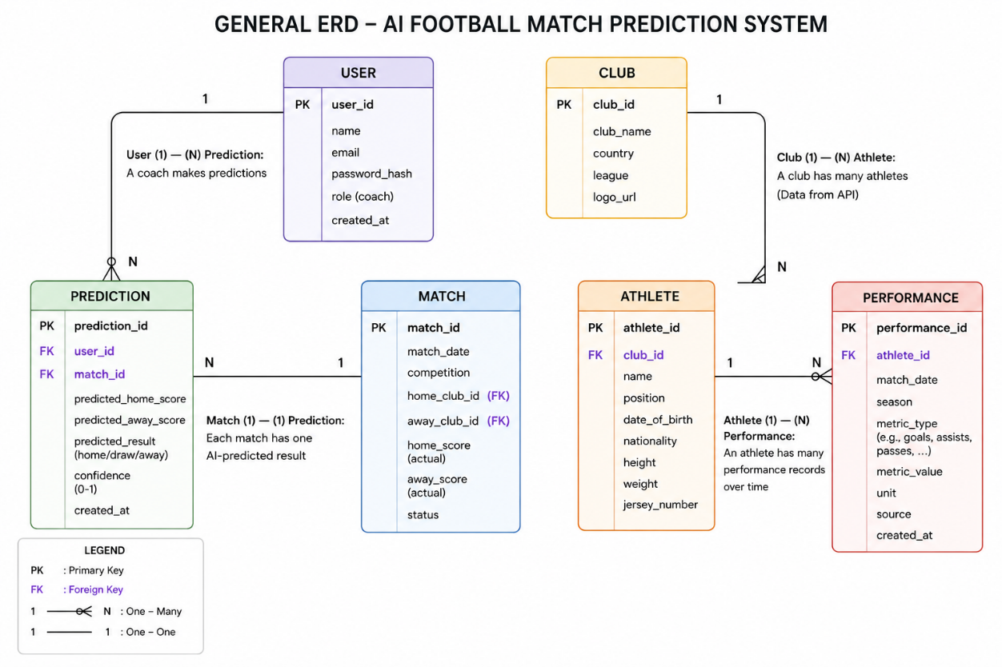
Figure 8: ERD of the Sports Performance Analysis System

3.2 Main Collections
Table 2: System Database Collections and Their Functional Purposes
Collection | Purpose
USER | Store coach/admin accounts
CLUB | Store football club information
ATHLETE | Store athlete profiles from API
PERFORMANCE | Store athlete statistics for dashboard charts
MATCH | Store match information
PREDICTION | Store AI prediction results

CHAPTER 4: BACKEND DEVELOPMENT & API

4.1 Backend Structure
The backend uses the server.js file as its primary launch point, built with Node.js and Express.js to handle requests from the frontend. The server handles API routing, connects to the MongoDB database, and integrates with the Football API via the fetch method.
During the login process, the user enters information on the frontend interface (Next.js). The data is sent to the backend via Axios. The backend checks the login information, compares it to the encrypted password, and authenticates the user. If valid, the system generates a JSON Web Token (JWT) consisting of an access token and a refresh token, then stores the refresh token in the database.
On the frontend, the token is stored and managed using Zustand. In subsequent API calls, Axios automatically attaches the access token to the request header. When the access token expires, the Axios Interceptor automatically sends a refresh token request to the backend to obtain a new token without interrupting the user experience.
After successful authentication, the user can access the system's functions. The backend then processes the request by calling the Football API via fetch, then checks, normalizes, and combines the data with internal information in MongoDB. Finally, the data is provided back to the frontend as an internal API for display on the dashboard.
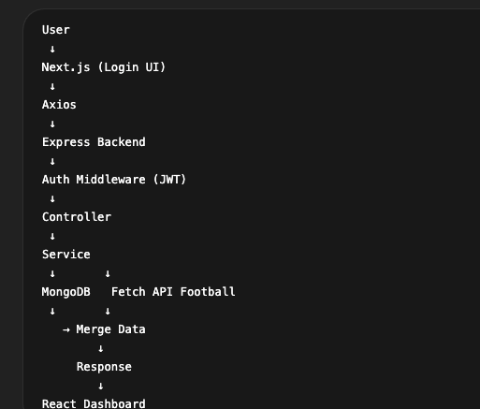
Figure 9: Backend Processing Flow and System Interaction Pipeline

4.2 API List and Processing Flows

4.2.1 User Management API
1. Login
→ User accesses the login page (Next.js + Tailwind CSS)
→ Sends a request via Axios to the backend
→ Backend (Express.js on Node.js) executes:
Backend flow:
- Receive login request
- Valigate input data
- Compare password (hash)
- Create JWT (access token + refresh token)
- Save refresh token to MongoDB
- Return token to frontend
→ Frontend saves token (Zustand) and passes to dashboard
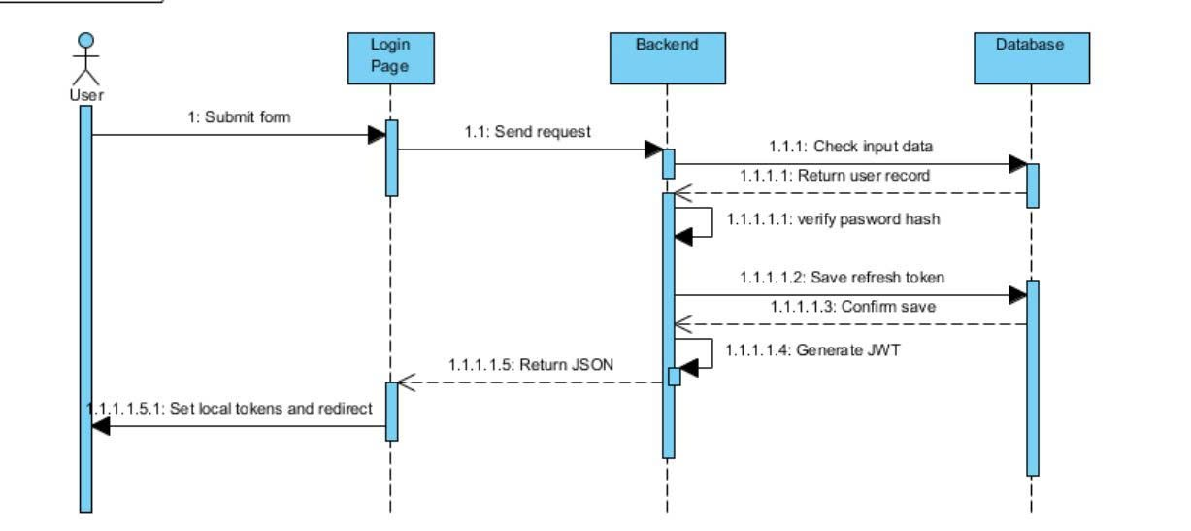
Figure 10: User Authentication Sequence Diagram
2. Importing Performance Data
→ Coach imports data on the dashboard (React JSX)
→ State management using Zustand
→ Send requests via Axios
Backend flow:
- Receive data from the request
- Validate data (schema validation)
- Normalize data format
- Proceed to the database saving step
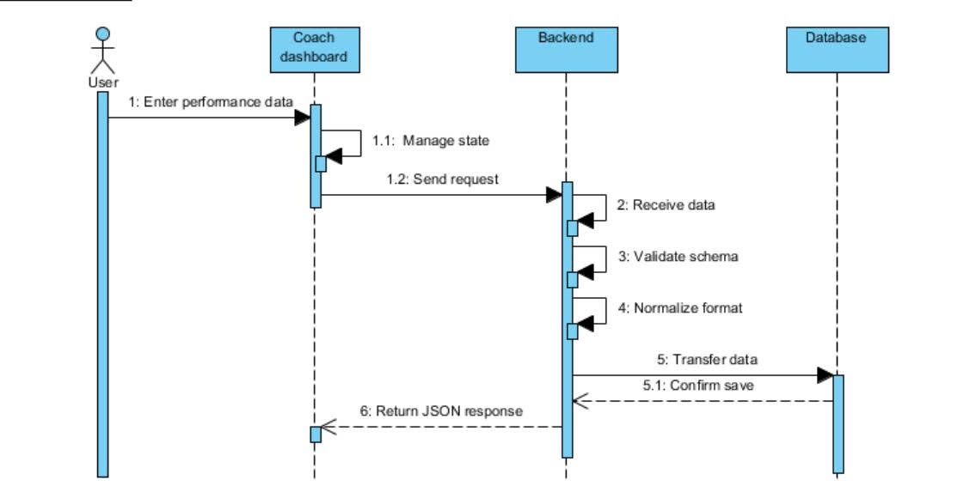
Figure 11: Performance Data Import Sequence Diagram
3. Save to Database
→ Backend operations with MongoDB
Backend flow:
- Map data to schema (User, Athlete, Performance)
- Write data to collection
- Process relationships (athleteId, matchId…)
- Return successful response
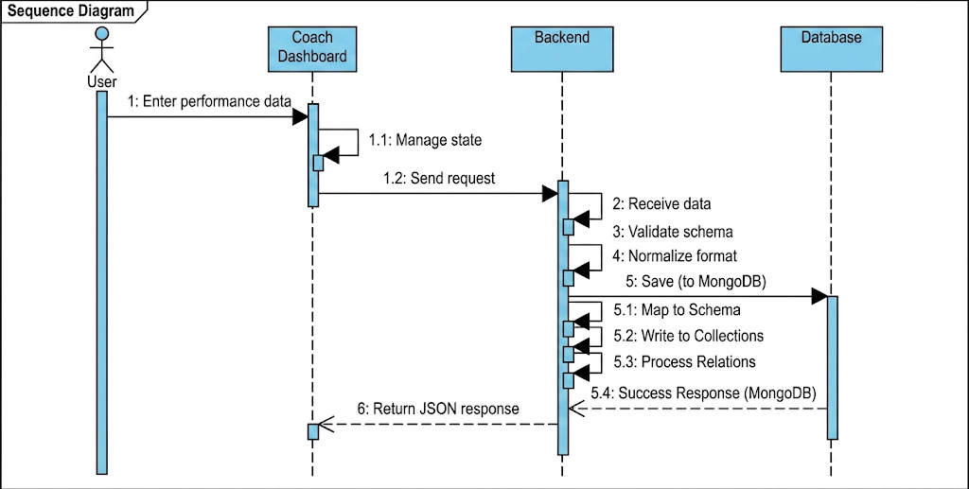
Figure 12: Sequence Diagram – Save Performance Data to Database
4. Backend Processing
→ This is the most important step
Detailed backend flow:
- Retrieve data from MongoDB
- Call external football API
- Combine internal and external data
- Execute:
- Calculate performance metrics
- Filter data based on criteria
- Aggregate statistics (average, sum, ranking, etc.)
- Cache (if applicable) to optimize performance
- Return processed data to the frontend
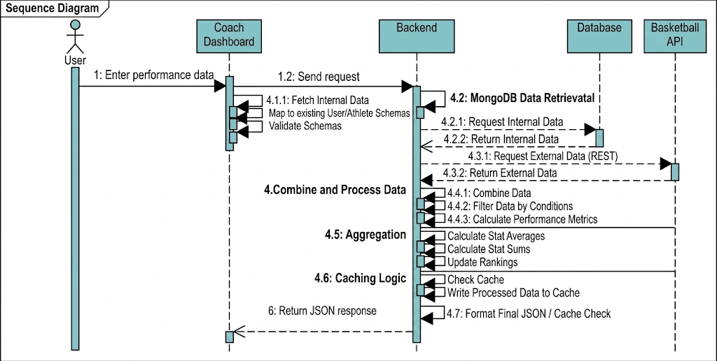
Figure 13: Sequence Diagram – Backend Processing Workflow
5. Dashboard Display
→ Frontend calls API via Axios (Interceptor automatically refreshes the token)
→ Receives data from backend
Backend flow:
Checks token (middleware authentication)
If token expires:
- Calls to refresh token
- Reissues access token
- Returns valid data
→ React render:
- Charts
- Statistics table
- KPI
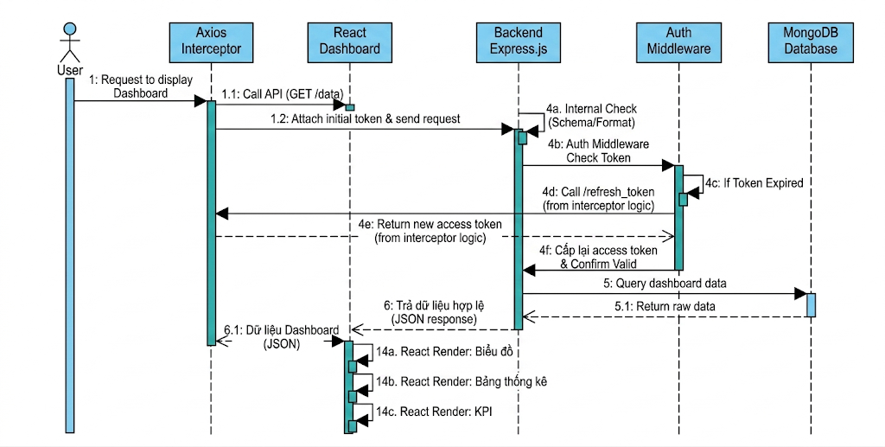
Figure 14: Sequence Diagram – Dashboard Display Flow
6. Data Analysis
→ Users analyze data on the UI
Backend support:
- Provides advanced filtering APIs
- Query by:
- time
- player
- match
- Returns data for in-depth analysis
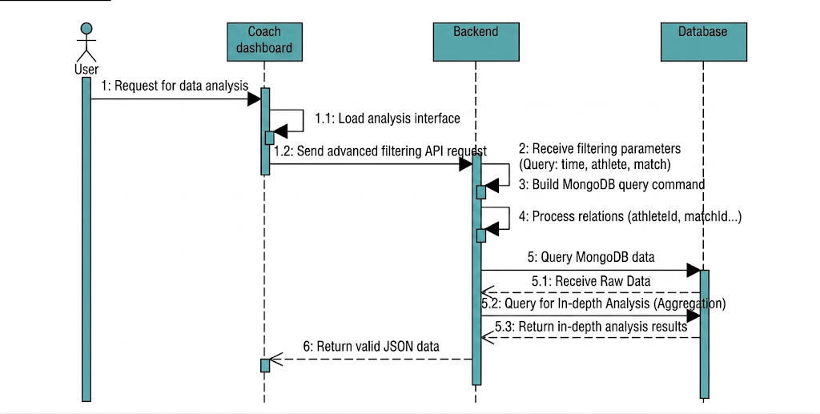
Figure 15: Sequence Diagram – Data Analysis Workflow
* General Backend Flow
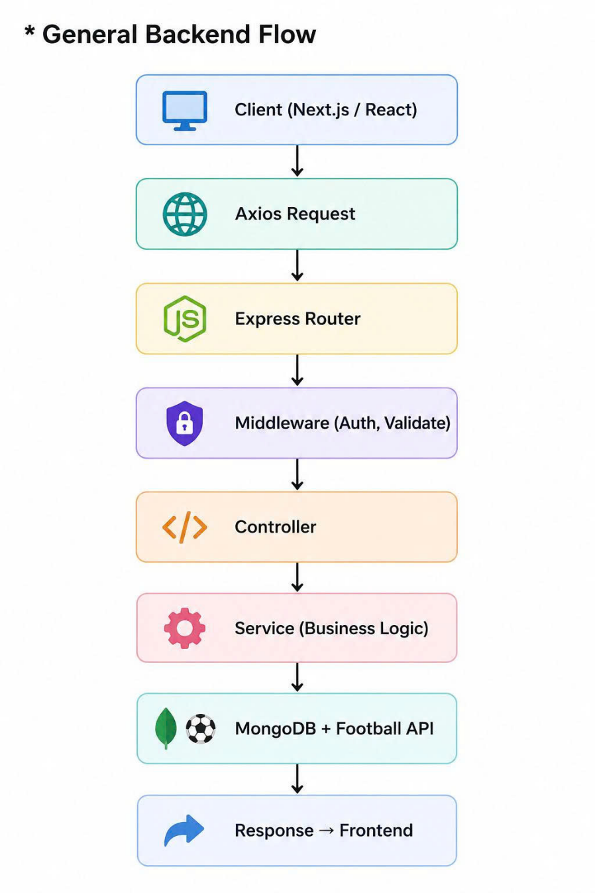
Figure 16: General Backend Flow Diagram
The system uses a third-party football API to supplement match data and athlete statistics. The backend acts as an intermediary in calling the API, processing, and providing the data back to the frontend.

4.2.2 API for processing logic and retrieving data from the Football API
1. Logical processing, purpose of integrating the Football API:
- Provide real-time match data (fixtures, results)
- Retrieve team and player information
- Add data for performance analysis
- Create dynamic data sources for the dashboard
2. How the backend calls the Football API
The backend uses the fetch method in the Node.js environment to call the external API.
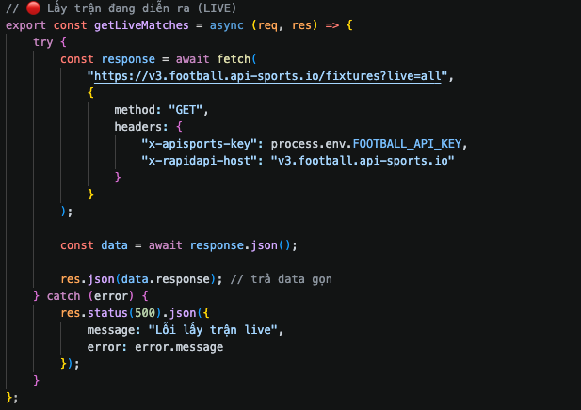
Figure 17: Backend Code for Calling the Football API
3. API Data Processing Procedure
After receiving data from the Football API, the backend performs the following steps:
* Processing Steps:
- Check for API response errors
- Filter necessary data (remove redundant data)
- Normalize data structure
- Mapping to internal system format
* Processing:
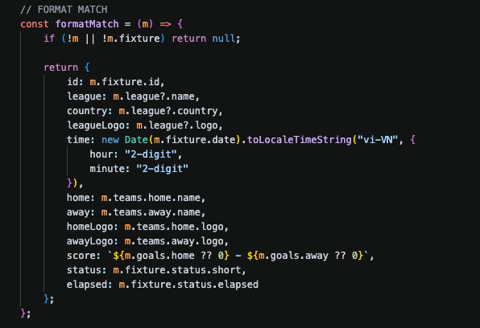
Figure 18: Match Data Normalization Function
4. Integration with Internal Data
The backend integrates data from the Football API with data in MongoDB:
- Linking athletes to matches
- Adding performance statistics
- Synchronizing data between the system and external sources
5. Providing Internal APIs to the Frontend
After processing, the backend builds its own API:
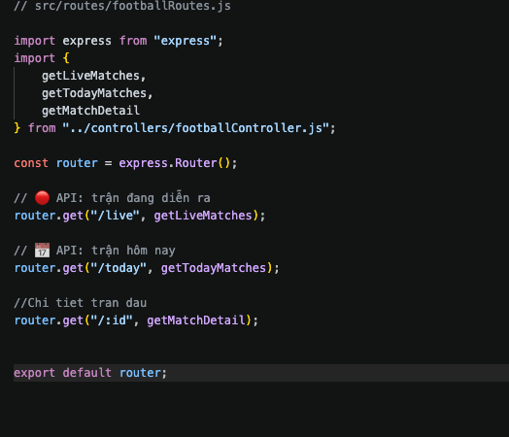
Figure 19: Backend API Routing Structure (Express Router)
API handling in the frontend
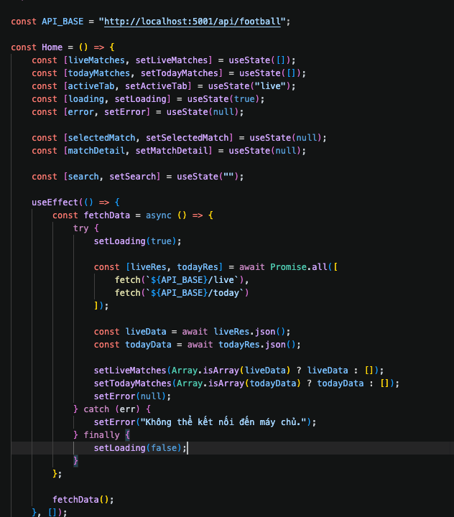
Figure 20: Frontend API Handling Logic
The frontend calls Axios to display the information on the dashboard.
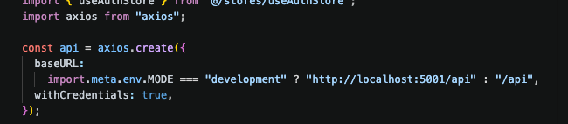
Figure 21: Frontend Axios Client Configuration
6. Reasons for using fetch in the backend:
- No need to install additional external libraries.
- Built-in in modern Node.js.
- Easy to use and suitable for REST APIs.

4.3 Authentication and Authorization System (JWT Authentication)

4.3.1 JWT Flow
- Register
- Email Verification
- Login
- Access Token
- Refresh Token
- Logout

4.3.2 API Protection Middleware Structure
Examples:
verifyToken → allow / deny
verifyAdmin → only Admin access
verifyCoach → only Coach access

4.3.3 List of Authentication APIs
Table 3: List of Authentication APIs
API | Method | Description
/auth/register | POST | Register & send verification email
/auth/verify-email | GET | Verify email
/auth/login | POST | Get JWT token
/auth/refresh | POST | Refresh token
/auth/logout | POST | Cancel login session

CHAPTER 5: INTERFACE DESIGN & DASHBOARD (4 pages)

5.1 Functional Screens
1. Homepage
The homepage serves as the first interface users encounter when accessing the system. This page provides an overview of the athlete performance analysis system, including its objectives, main functions, and benefits. Additionally, the homepage allows users to easily navigate to important functions such as login or account registration.
The page is designed with a simple, intuitive interface, helping users quickly understand the system's purpose and begin using it.
→ Technology:
- React (JSX)
- Tailwind CSS
2. Login Page
The login page allows users to enter their account information (username/email and password) to access the system. When a user submits their login information, the system sends a request to the backend for verification. If the information is valid, the system issues a token (JWT) and allows the user to access internal functions such as the dashboard and data analysis.
This page also ensures information security through password encryption and the use of a modern authentication mechanism. In addition, the system supports automatic token renewal upon expiration, ensuring an uninterrupted user experience.
→ Technology:
- React (TSX)
- Tailwind CSS
- Axios
- Zustand
3. Registration Page
The registration page allows users to create new accounts by entering necessary information such as username, email, and password. The system will check the validity of the input data (e.g., email format, password strength) before sending it to the backend for storage in the database.
After successful registration, users can log in to use the system's functions. This page expands accessibility and allows multiple users to easily join the system.
→ Technology:
- React (TSX)
- Tailwind CSS
4. Dashboard Page
The dashboard page is the heart of the system, displaying an overview of data and key metrics related to athlete performance. This page provides information such as the number of matches, performance, KPIs, and aggregated statistical data.
Data is displayed in the form of charts and tables, making it easy for users to observe and assess the situation visually. The dashboard supports real-time data updates through API calls from the backend.
→ Technology:
- React (JSX)
5. Performance Analysis Page
The performance analysis page provides in-depth analytical tools for athlete data. Users can view detailed metrics such as goals, assists, distance covered, and performance over time.
In addition, the system supports performance comparisons between athletes or between different matches, helping coaches make more accurate decisions in adjusting tactics and training.
This page plays a crucial role in data mining and transforming data into valuable information.
→ Technology:
- React (JSX)
6. Settings Page
The settings page allows users to manage personal information and account-related settings. Users can update personal information, change passwords, and configure system options.
This page ensures personalization and security for users, helping them control their accounts easily and safely.
→ Technology:
- React (JSX)
7. Support Page
The support page provides system usage instructions, answers frequently asked questions (FAQs), and assists users with troubleshooting.
Additionally, this page can integrate contact channels such as email or support request forms, making it easy for users to contact administrators or the development team.
The support page contributes to improving the user experience and ensuring the system operates efficiently.
→ Technology:
- React (JSX)

5.2 Statistical Charts & Visualizations
This section describes the statistical charts and visualization process used in the Football Analytics AI Platform. The goal is to transform football match data, AI predictions, and player/team statistics into interactive visual insights that support analysis, prediction, and decision-making.
- Objectives
- Visualize football statistics in real time.
- Display team and player performance trends.
- Support AI prediction analysis through probability charts.
- Provide interactive analytics dashboards for users.
- Improve understanding of datasets and machine learning results.
- Visualization Workflow
- Data Collection: Collect football data from API-Football, PostgreSQL database, and AI prediction models.
- Data Processing: Clean and normalize data such as possession, shots, goals, win rate, and player ratings before visualization.
- Statistical Analysis: Calculate match statistics, form trends, scoring averages, defensive performance, and prediction probabilities.
- Chart Generation: Generate interactive charts using Recharts in React frontend.
- Dashboard Integration: Display charts dynamically inside Dashboard, Match Detail, Analytics, and AI Hub pages.
- Real-Time Updates: Update live match charts automatically using API synchronization and background refresh.
- Types of Statistical Charts
Chart Type | Purpose | Page
Line Chart | Display team form and performance trends over recent matches. | Analytics
Bar Chart | Compare goals, assists, shots, and player statistics. | Dashboard Players
Pie Chart | Show possession percentage and win/draw/loss distribution. | Match Detail
Radar Chart | Compare attacking and defensive performance between teams. | Analytics
Area Chart | Visualize live match momentum and xG trends. | Match Detail
Probability Chart | Display AI prediction confidence for win/draw/loss. | AI Hub
- Technology Used
  - React 19 for frontend rendering.
  - Recharts for statistical visualizations.
  - TanStack Query for real-time data fetching.
  - MongoDB for structured football statistics.
  - Custom AI models for prediction analytics.
- Expected Results
  - Interactive and responsive analytics dashboard.
  - Improved understanding of football statistics.
  - Clear visualization of AI predictions.
  - Efficient comparison between teams and players.
  - Real-time monitoring of ongoing matches.
- Conclusion
The Statistical Charts & Visualizations module plays an important role in the Football Analytics AI Platform. By combining real-time football data, machine learning predictions, and interactive charts, the system provides users with a modern analytical environment for football analysis and decision support.

CHAPTER 6: DATA ANALYSIS

6.1 Data is collected from the API-Football service
- After retrieving the data, it is returned in JSON format (raw data).
Figure 22: Sample Raw JSON Data Returned from API-Football

6.2 Data Preprocessing
Objective
- Clean the data
- Standardize the data
- Only select valid matches
- Convert data formats

6.2.1 Data Cleaning
Handling Missing Data
Some match data may be incomplete.
Examples:
- Missing possession
- Missing shots
- Missing goals
- Processing methods:
- Replace with 0
- Replace with average values
- Remove corrupted matches
Removing Unnecessary Data
- Some information is not needed for AI training.
Examples:
- Team logo
- Referee
- Stadium image
These fields are removed to reduce unnecessary data.
- Data Standardization
The data must follow the same format before training the AI model.
Examples:
- Convert all team names into a consistent format
- Convert date and time into timestamp format

6.2.2 Selecting Valid Matches
Use:
- Finished matches (FT)
Do not use:
- Live matches
- Postponed matches
- Cancelled matches

6.2.3 Sorting Data by Time
Each team needs historical match data.
The system collects:
- The latest 5 matches for each team
Example:
Arsenal:
- Match 1
- Match 2
- Match 3
- Match 4
- Match 5

6.3 Converting JSON into Dataset
AI models require structured tabular data.

Figure 23: Example of Structured Dataset Converted from JSON
The JSON data will be converted into:
- CSV
- Excel

6.4 Feature Engineering (AI Prediction)
The system uses two main AI models:
- Logistic Regression
- Random Forest

6.4.1 Collecting the Latest 5 Matches of Each Team
Arsenal:
- Win
- Draw
- Win
- Win
- Loss
Chelsea:
- Loss
- Draw
- Win
- Loss
- Draw

6.4.2 Calculating Average Statistics
Team A
- Average goals
- Average shots
- Win rate
- Average possession
Team B
- Similar statistics

6.5 AI Training

6.5.1 Preparing Training Data
After completing:
- Data preprocessing
- Converting JSON into tables
- Feature engineering
The system will generate:
- Input dataset (features)
- Output dataset (labels)
- Input Data
The input contains statistics calculated from the latest 5 matches of both teams.
Team A
- Average goals
- Average shots
- Average possession
- Win rate
- Scoring efficiency
- Average goals conceded
Team B
- Similar statistics
- Meaning of Input Data
The input represents:
- Current form
- Attacking strength
- Defensive efficiency
- Match control ability
The AI learns the relationship between these statistics and match outcomes.

6.5.2 Data Labeling
Each row of data must contain the actual match result.
Labels include:
- HOME_WIN
- DRAW
- AWAY_WIN
- Role of Labels
Labels are the correct answers used for AI learning.
The AI will:
- Compare input data
- Compare with actual results
- Learn prediction patterns

6.5.3 Splitting Training and Testing Data
The dataset is divided into two parts:
- Training Set
- Testing Set
Approximately 70–80% of the data is used as the Training Set.
- Training Set Purpose
- Train the AI model
- Help the model learn patterns
Approximately 20–30% of the data is used as the Testing Set.
- Testing Set Purpose
- Evaluate prediction accuracy
- Test prediction ability on new data

6.5.4 Selecting AI Models
For football match prediction, suitable models include:
- Logistic Regression
Suitable because:
- Easy to implement
- Easy to explain
- Suitable for statistical data
The model will:
- Calculate win/draw/loss probabilities
- Classify match outcomes
- Random Forest
Suitable because:
- Handles nonlinear data well
- Provides higher accuracy
- Reduces overfitting
The model works using:
- Multiple decision trees
- Combined prediction results

6.5.5 AI Training Process
During training, the AI will:
- Read training data
- Analyze relationships between statistics and match outcomes
- Adjust weights
- Reduce prediction errors
- Optimize the model
- What Does the AI Learn?
Examples:
- Teams with higher win rates tend to win
- Teams with more dangerous shots perform better
- High possession improves match control
- Recent performance strongly affects outcomes

6.5.6 Evaluating the AI Model
After training, the model quality must be evaluated.
- Accuracy
Measures:
- Percentage of correct predictions
- Precision
Measures:
- Prediction accuracy for each prediction class
- Confusion Matrix
Used to:
- Compare predictions with actual results
- Identify where the AI makes mistakes

6.5.7 Model Optimization
If the accuracy is low:
- Increase training data
- Improve feature engineering
- Remove noisy data
- Add important statistics
Factors That Can Improve AI Performance
- Home/away advantage
- Head-to-head history
- Winning/losing streaks
- Fatigue
- Average goals conceded
- Defensive efficiency

CHAPTER 7: CONCLUSION

7.1 Achieved Results
This project successfully developed a prototype of the Sports Performance Analysis System Using Big Data, providing essential functionalities for athlete monitoring and performance analysis. Key results include:
- A complete three-layer system architecture (Frontend – Backend – Database).
- JWT-based user authentication, including login, registration, email verification, logout, and token refreshing.
- Athlete management modules allowing creation, update, and deletion of athlete profiles.
- Performance data input, supporting manual entry and file imports with validation.
- Analytics dashboard with charts and statistical summaries for performance evaluation.
- RESTful APIs for data processing and communication between system layers.
- A structured MongoDB database storing users, athletes, matches, and performance data.
- Full technical documentation, including Use Cases, UML diagrams, ERD, and UI designs.
Overall, the system demonstrates how Big Data can support data-driven decision-making in sports performance management.

7.2 Limitations & Future Work
Limitations
- The dataset is small and does not include real-time sensor data.
- Analytics are basic; no predictive modeling is included.
- UI is functional but not yet optimized.
- System not tested under large-scale performance loads.
- Authentication features are minimal and not production-hardened.
Future Work
- Integrate machine learning for prediction and deeper analysis.
- Support real-time data streaming from IoT and wearable devices.
- Add advanced visualizations such as heatmaps and dynamic dashboards.
- Optimize backend performance and database indexing.
- Enhance security, scalability, and UI/UX quality.
- Deploy on cloud platforms for real-world usage.

REFERENCES
[1] Giáo Trình Phân Tích Dữ Liệu Lớn - Đỗ Phúc (ĐHQG TP.HCM 2019)
https://www.studocu.vn/vn/document/truong-dai-hoc-cong-nghe-thong-tin-va-truyen-thong/phan-tich-thiet-ke-huong-doi-tuong/giao-trinh-phan-tich-du-lieu-lon-nxb-dai-hoc-quoc-gia-2019-do-phuc-230-trang/80670302
[2] TỔNG QUAN VỀ DỮ LIỆU LỚN (BIGDATA)
https://www.academia.edu/33733128/T%E1%BB%94NG_QUAN_V%E1%BB%80_D%E1%BB%AE_LI%E1%BB%86U_L%E1%BB%9AN_BIGDATA
[3] Eager, E. & Erickson, R. (2023). Football Analytics with Python & R. O'Reilly
https://www.oreilly.com/library/view/football-analytics-with/9781492099617/
[4] Rein, R. & Memmert, D. (2016). "Big data and tactical analysis in elite football: A systematic review". International Journal of Sports Science & Coaching, 11(4), 585-596.
https://journals.sagepub.com/doi/10.1177/1747954116653450

